EXAMPLE Clock Personalisation Template (regular sized Weather Clock)
This is a document designed to allow you perfect the design of your personalised weather clock. Use it to play about with different wording and fonts. When viewed at ‘100%’ it should appear life size, though you will probably find this easier to use if you zoom out a little.

- Click on the text in the centre of the clock. This will open up the text box in which the text ‘Insert your text here’ has been written.
- Edit to your hearts content! You can try all manner of different wording and formats until you’re happy e.g. play about with bold/italic/size/capitalisation. You can even move or resize the text box if you wish.
- Should you wish the font to match the one used in the Bramwell Brown logo on the clock face, we suggest using Times New Roman.
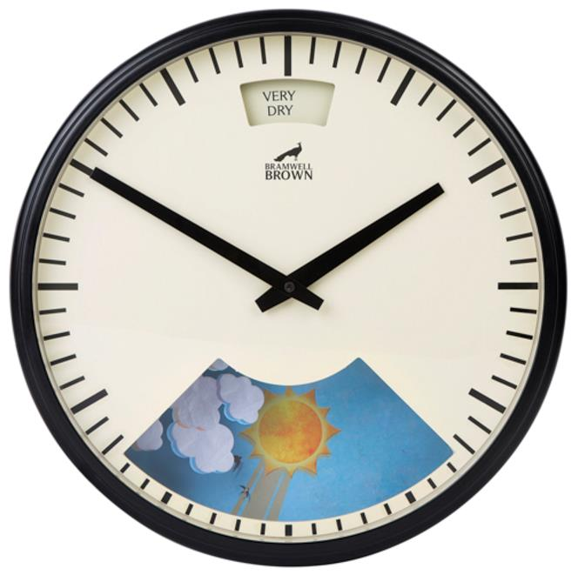

Insert Your Text Here

